Performance Assessment Worksheet

In order to assist us in diagnosing the cause of your Editorial Manager System slowdown report, please complete the following worksheet. Because changes in internet connections can occur quickly, the more rapidly you can complete and return the form, the more accurately we can diagnose your issue.

Please indicate your geographic location

Please describe what kind of task when you were performing when you experienced slowness.
e.g. Performing technical check / Assigning editor / inviting reviewer / checking details, history link in action links.
How many seconds did slowness last?
Did any error appear? Did the error appear immediately?
Please attach video or screenshots where possible.

Kindly provide the exact time that this happened. Please note time zone e.g. GMT

Please perform a “trace route” to www.editorialmanager.com
Note: It is important that the trace can get to the navisite.com address, which is the last hop before the Aries firewall.
To run a trace on a PC:
- Click on start → programs → accessories → command prompt
- Enter the following: tracert www.editorialmanager.com
- To get a screen shot, use ALT + Print Screen. Open MS Word and select edit → paste to paste the image into a new document. Send this document back to Aries.
- To copy the information to a clipboard for pasting into a document or email, use Ctrl + V to paste the information into your email or document

To run a trace on a Mac:
- Bring up terminal found under applications → utilities
- Enter the following: traceroute www.editorialmanager.com
- To copy the information to a clipboard for pasting into a document or email, click edit → select all. Select edit → copy and then paste the information into a text document or email.

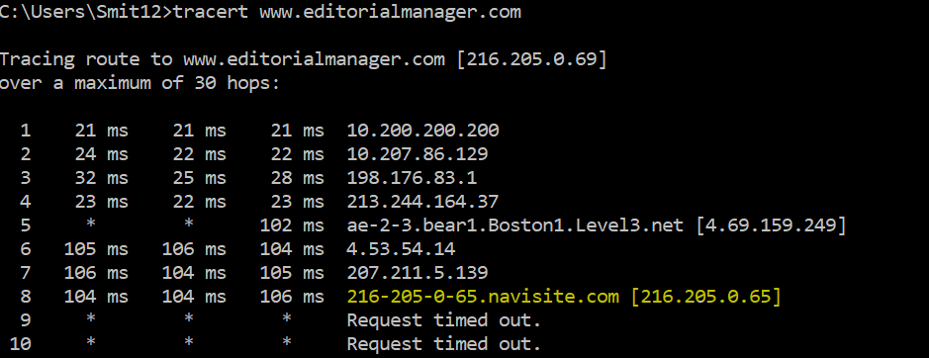

Perform a speed test at www.speedtest.com

- Go to www.speedtest.net
- Click on ‘Change Server’ and type in ‘Boston’ in the box. Select either server.
- Click on ‘GO’ and copy and paste the results here.

